Hiring Hartford Methodist Church Hall

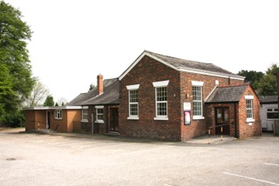

Rooms Available for Hire
There are two rooms at the Church Hall for individuals or groups to hire – the main hall and a smaller meeting room. The kitchen can also be hired in addition to the other rooms should it be needed.

The Main Hall is 40ft x 25 ft (12m x 8.65m) with a wood block floor. It is a light and airy room. It can seat up to 100 people concert style. A portable screen is available.

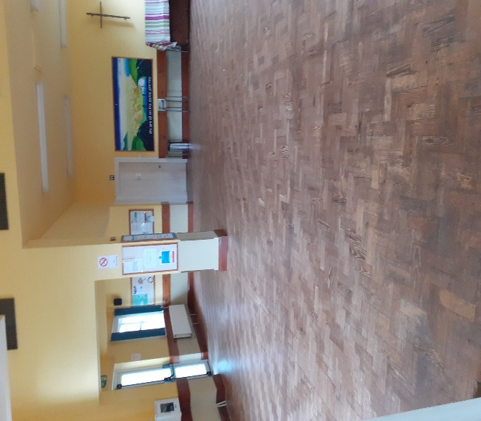

It has an entrance door from the front of the Hall and a door through to the kitchen.
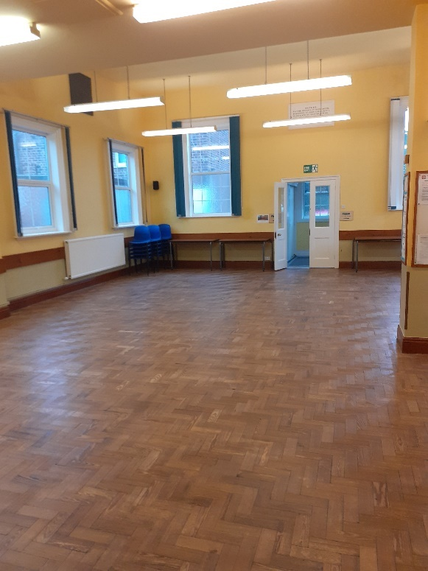

The Meeting Room is 20ft x 15ft (6m x 4.5m) with carpet tiles on the floor. The room caters for smaller groups, typically Art and Craft and Discussion groups of up to 15 people. It can seat up to 30 people concert style.
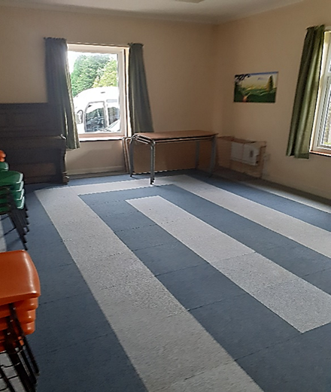
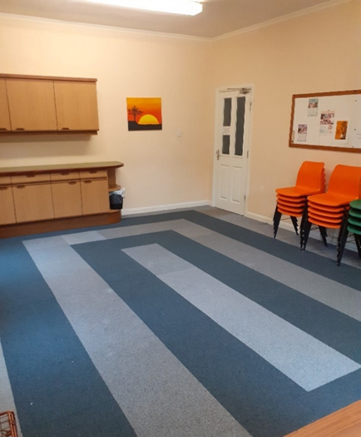

The Kitchen is 15ft x 15ft (4.5m x 4.5m) and is equipped with a stainless-steel sink, hot water heater, electric cooker, 4 ring hob, a microwave and an electric kettle. The First Aid Kit, Accident Book and Health and Safety Manual are kept in the kitchen. Doors lead to the back entrance corridor and also into a middle hall through to the main hall. A wide range of crockery, kitchen utensils and cutlery are available for hirer use.
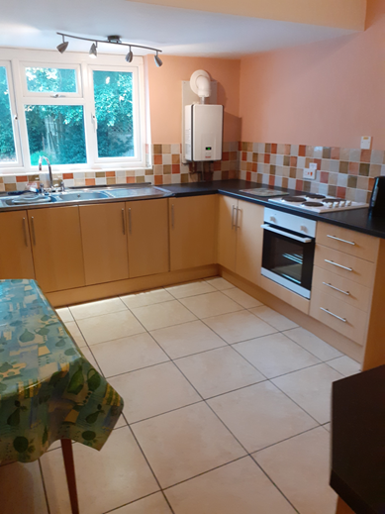
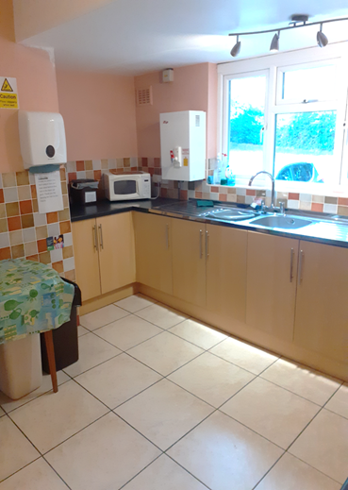

Disabled Access
All rooms are accessible so there are no steps to negotiate. There is a disabled ramp to the main entrance door and rear entrance door.
The disabled toilet is located off the rear entrance hall.

Car Park
There is space for 26 cars on the top car park including 3 disabled spaces and 20 plus on the overflow car park at the rear of the Hall.

Current Fees
Hourly Rate Main Hall £8 per hour, Meeting Room £6 per hour, Kitchen £1 per hour
Payment Terms Quarterly within 10 days from receipt of an invoice from the Managing Trustees.

Hall Access
Entrance to the Hall is gained using a code to obtain the door key. The door code will be issued once all the paperwork and induction has been completed.

Contacts
To discuss the availability of the rooms, book a viewing please contact our Booking Secretary Theresa Cunningham Tel. 01606 889721 or Mob 0771025889, or use the Contact Us page on this website.

